**Cybersecurity Tools & Techniques**

**Meta:** Wondering what’s in a cybersecurity pro’s toolbox? **Spoiler**: it is not just antivirus and crossed fingers. From packet sniffers to threat hunters, here’s how we fight the internet’s dark side (with logs, scripts, and caffeine).

Photo by [Afif Ramdhasuma](https://unsplash.com/@javaistan?utm_source=medium&utm_medium=referral) on [Unsplash](https://unsplash.com/?utm_source=medium&utm_medium=referral)

**1. What Are Cybersecurity Tools & Techniques?**

Imagine trying to stop a cyberattack without tools. That’s like fighting a dragon with a pool noodle (or a plastic spoon).

Cybersecurity tools are the magical artifacts, and techniques are the spells. Together, they help defenders detect, prevent, and respond to all the nonsense the internet throws at them ranging from bored teenagers with Metasploit to nation-states with time and budget.



Hehe. Credit: Giphy

This isn’t just about running Nessus and calling it a day. It’s understanding what is under the hood, how attackers operate, and how to break their toys before they break yours.

**2. Categories of Tools (Choose Your Own Weapon)**

* **Reconnaissance & Scanning**

Common Recon Tools.

Because finding your own open ports before the attackers do is kind of important.

* **Vulnerability Management**

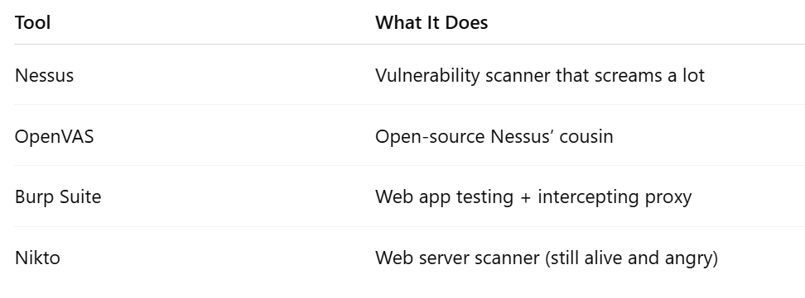

Common Vulnerability Tools.

Running these won’t fix your problems, but at least you’ll know how doomed you are.

* **Monitoring & Detection**

Common Monitoring Tools

Because logs are love. Logs are life.

* **Forensics & Incident Response**

Common Incident Response Tools

If you like playing detective but with hex and timestamps, welcome to the world of forensics.

* **Threat Intelligence**

Common Threat Intelligence Tools

Because knowing what’s out there beats screaming “WHAT WAS THAT” into the dark black hole.

**3. Techniques: How the Cyber Pros Actually Use These Things**



Technique. Credit: Giphy

* **Recon & Enumeration**

Find the target’s digital footprint. Subdomains, emails, exposed devices. It’s like cyberstalking, but legal (mostly).

* **Exploitation**

Find a vulnerable service, break into it, profit. Red teamers use this. So do the bad guys. So do interns when they misconfigure Jenkins.

* **Log Analysis**

Filter through 1.2 million entries of “Successful Login” to find the one that shouldn’t be there. Think: Where’s Waldo, but Waldo is a threat actor, and your job depends on spotting him.

* **Hardening**

Turning off unnecessary services, patching, changing default creds, basically being the adult in the room.

* **Threat Hunting**

Looking for threats before alerts pop up. Half intuition, half “read too many threat reports,” all anxiety.

* **Incident Response**

When things go boom, you come in. Isolate. Contain. Erase. Report. Repeat. Bonus points if you do it before the media finds out.

**4. Common Scenarios (and the Tools That Save You)**



Headache Scenario. Credit: Giphy

**Phishing Attack:**

* Use: Email header analysis, VirusTotal, URLScan.io
* Response: Quarantine, report, cry slightly

**Lateral Movement Suspected:**

* Use: Zeek, Sysmon, EDR tools
* Response: Log correlation, account lockdown, SOC war room time

**Unknown Binary Found:**

* Use: Cuckoo Sandbox, Any.Run, Ghidra
* Response: Reverse engineer or dropkick into a VM

**Web App Breach:**

* Use: Burp Suite, Nikto, OWASP ZAP
* Response: Fix inputs, change passwords, review backend with a side of shame

**5. How to Actually Learn These Tools (Not Just Install Them and Forget)**

* **TryHackMe / Hack The Box:** Labs that don’t actually suck
* **BlueTeamLabs / CyberDefenders:** Detection/IR challenges
* **CTFs:** Where sleep goes to die, but skills grow fast
* **Security Onion:** Build your own detection playground
* **GitHub:** Everyone’s dumping ground for “scripts that work most of the time”

Practice doesn’t make perfect. Practice makes you less confused when the real alert hits.

**6. Mistakes to Avoid (Yes, You. Please Stop That.)**

* Using tools you don’t understand (“I clicked scan and nothing happened…”)
* Ignoring alerts because they seem “spammy”
* Not configuring your tools properly (default creds still on ELK)
* Copy-pasting scripts from Reddit with zero context
* Thinking tools will replace knowing how stuff actually works

Tools are helpers, not magic wands. You are the wizard.

**7. Who Uses These Tools?**

Some Roles and Some Tools

**TLDR**

Cybersecurity tools and techniques are how defenders stay one step ahead of attackers or at least break even. Don’t chase every shiny tool; learn the ones that matter. And always RTFM.

***Quiz Time***

1. **What’s Nmap used for?**

a) Making memes  
b) Network scanning  
c) Detecting phishing  
d) Fixing printers

**2. Which tool is used for log correlation?**

a) Splunk  
b) Photoshop  
c) Nikto  
d) Netcat

**3. What’s the first step in incident response?**

a) Reboot the server  
b) Panic  
c) Identify the incident  
d) Delete logs

*(Answers: 1b, 2a, 3c — you’re welcome)*

**Enjoyed the read?**  
Smash the follow button, drop a comment, and share this with someone who still thinks “password” is a good password.

If you enjoyed the reading, kindly subscribe to my page: [Here](https://medium.com/@Ethical_DarKVoicE/subscribe)

More chaos, hacks, and knowledge coming soon. Stay safe, stay paranoid.